Video Creation Techniques

Pre-planning – Get as much information from client as possible.
- Helps you work efficiently. Goal is to make as few adjustments as possible before the final product.
- Ask questions like:
  - How long do you want the video/s to be?
  - What is purpose or end goal for the video/s?
  - What graphic elements do I need?
    - Logos
    - Color scheme
    - Style guide
  - What tone do you want the video/s?
  - Music, do you have an example of something you like?
  - Do you have example of another video/s that you like?

Shooting
- Location
  - Studio
  - In Field
- Lighting
  - Tube Lights (need to get examples)
    - Mobile
    - Colors
  - LED Lights
  - Reflectors
  - Fog machine
- Audio
  - Most important part of interviews/scripted content
  - Have headphones!!!
- Camera Settings
  - In Focus
  - Shutter/Aperture/ISO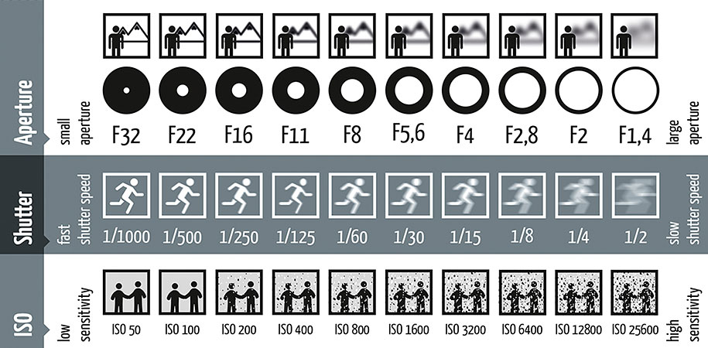
- B-Roll
  - Get tons of B-roll, more than you think
  - Closeup, wide shots, mid shots, facility, aerial, action
  - Capture footage after interviews based on content discussed in the interview
    - If person discusses cars, and tires on cars… get footage of cars and closeups of tires on cars.
- Graphics/Motion Graphics
  - Lower 3rds
  - Copywriting
  - Style
  - Stock Footage
    - Motion Array
    - Storyblocks
  - Essential Graphics
- Music/Sound FX
  - Licensing
    - Motion Array
    - Storyblocks
- Editing
  - Organize your footage and project
    - Folders with Dates
      - name your footage
  - Use Bins to organize your project
    - Footage
    - Graphics
      - Logos
      - Essential GFX
    - Music/SoundFX
    - Sequences
      - Finals

